**Software Engineering Tools Lab**

**Assignment No-8**

**Module 5- Software testing using tools**

**PRN: 2020BTECS00079**

**Name: Saurabh Khadsang**

**Q 1. What are the prerequisites for installing the TestLink tool.**

Operating System: Windows, Linux, or Mac OS X

**xampp-5.6.36**

Web Server: Apache or IIS

Database: MySQL, PostgreSQL, or Microsoft SQL Server

PHP: Version 5.6.x or higher

PHP Extensions: mbstring, gd, xml, mysqlnd, mysqli or pdo_mysql, zip

Browser: Any modern web browser such as Chrome, Firefox, or Safari

**Q 2. Install TestLink tool on your machine (Provide screen shots for successful installation and login)**

1. Download the latest stable version of TestLink from the official website (<https://testlink.org/>).
2. Extract the downloaded ZIP file to a directory on your machine.
3. Copy the extracted TestLink folder to your web server's document root directory.
4. 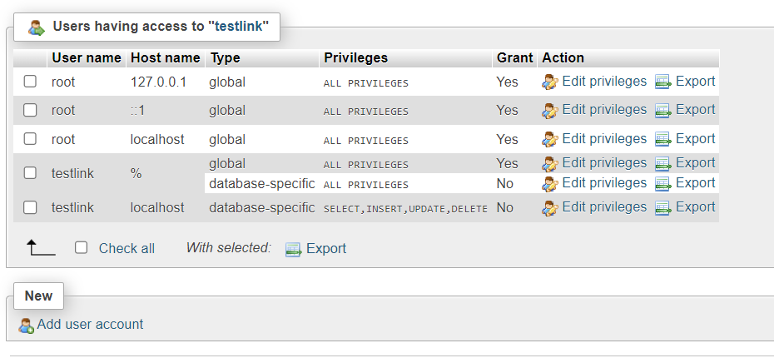Create a new database for TestLink and grant a user with necessary privileges to access the database.
5. Rename the configuration file config.inc.php.sample to config.inc.php and modify the necessary configuration settings such as database connection details.
6. Open a web browser and navigate to the TestLink installation URL (e.g., <http://localhost/testlink/install/index.php>).
7. Follow the on-screen instructions to complete the installation process, providing the necessary details such as database connection details and administrator account information.
8. Once the installation is complete, login to TestLink using the administrator account that you created during the installation process.

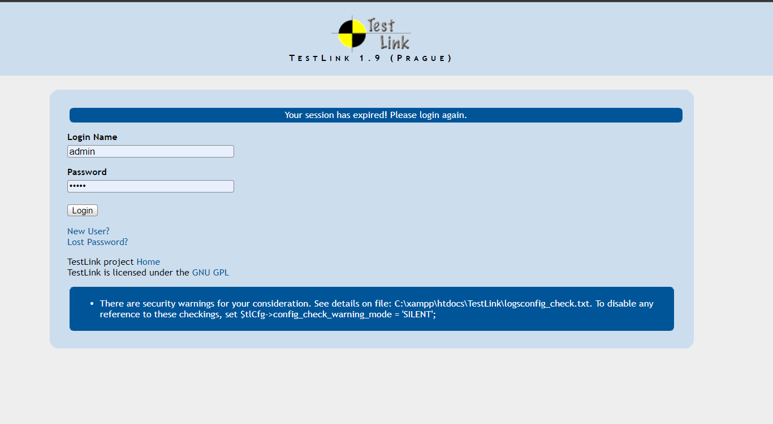

Q 3. Using TestLink tool create multiple test cases (at least 10) on any application/project that you have implemented.

Perform below tasks

1. **Create New test project as SETProject**

Login to TestLink

Click on "Create new test project" under the "Test Project Management" tab

Enter the project name as "SETProject"

Enter a brief description of the project

Select any relevant options like enable requirements management, test plan management, etc.

Click on "Create Test Project"

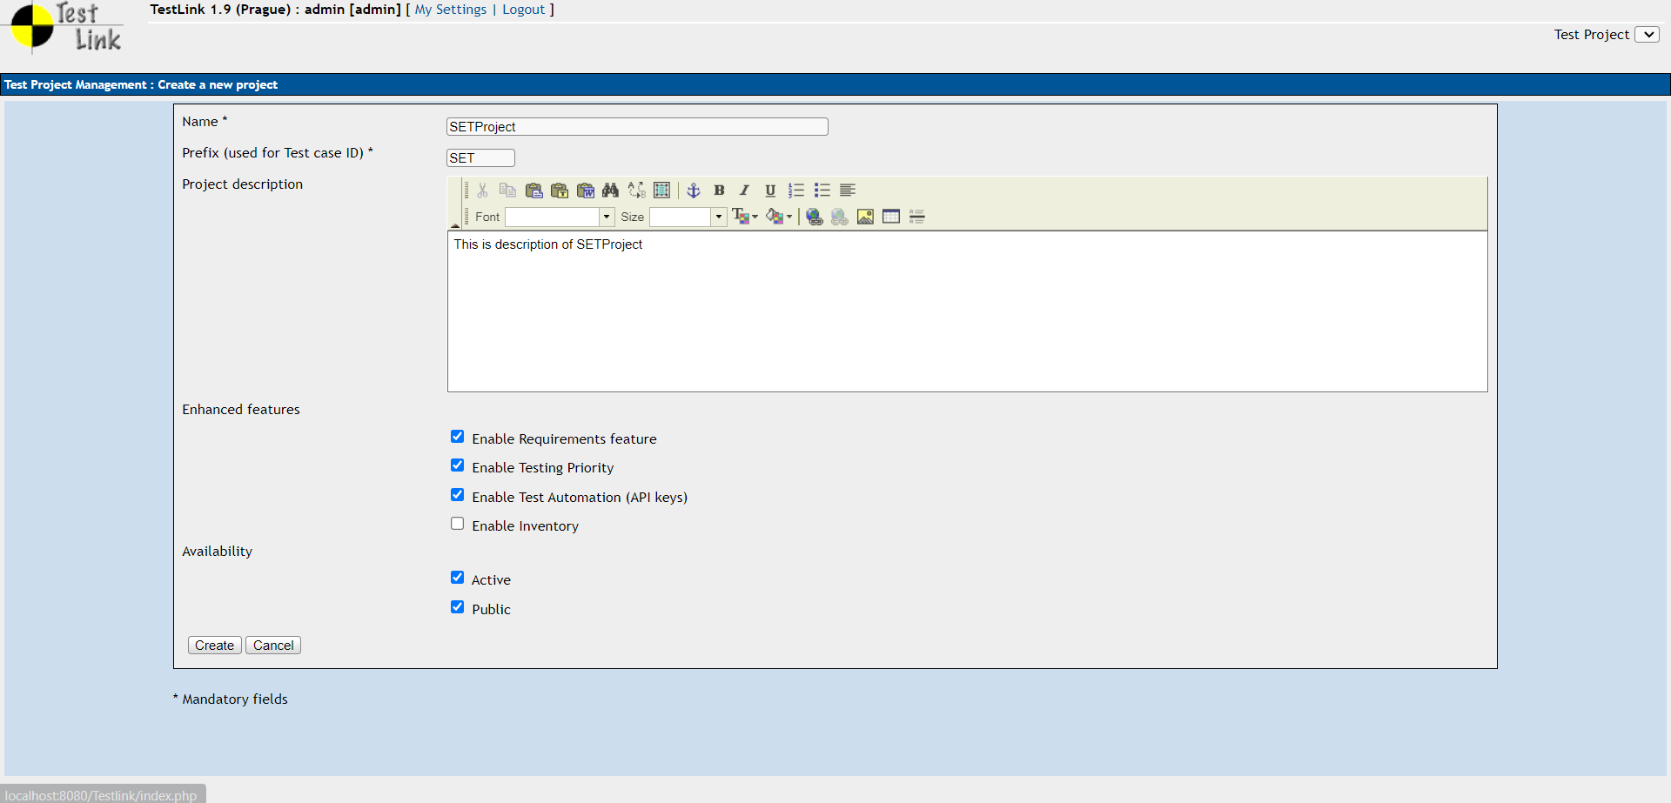

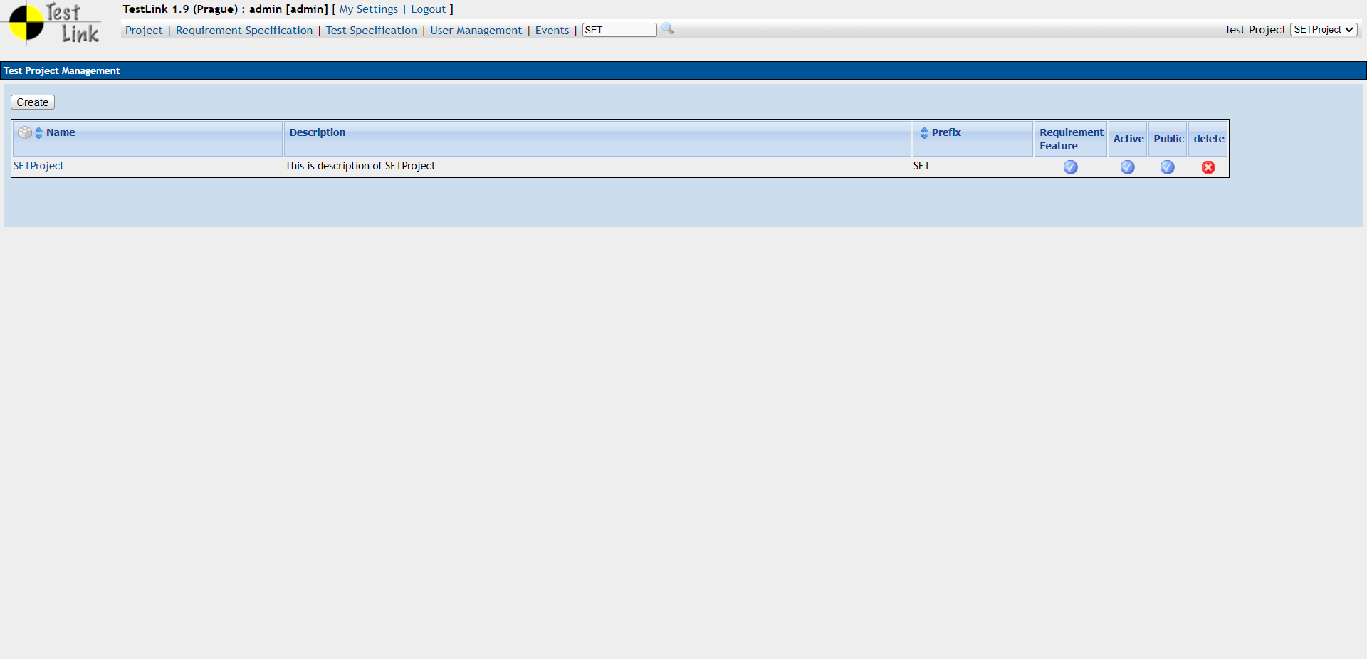

1. **Create a test plan as SETProjectTestPlan**

Click on the "Test Plan Management" tab

Click on "Create Test Plan" under SETProject

Enter the test plan name as "SETProjectTestPlan"

Enter a brief description of the test plan

Select the test cases to be included in the test plan

Click on "Create Test Plan"

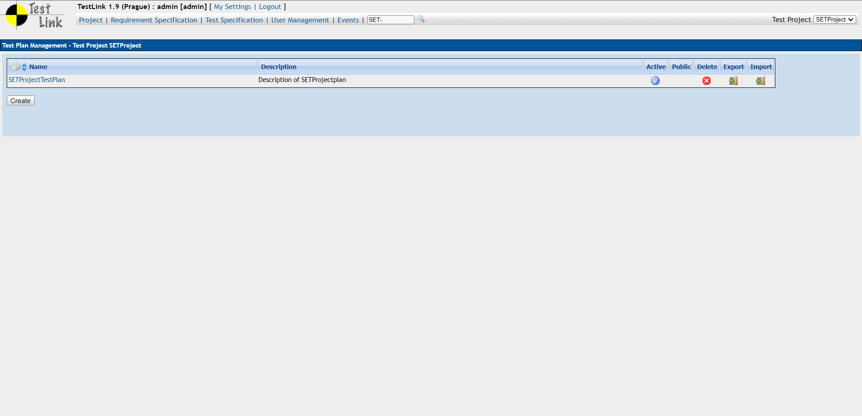

1. **Create a build as SETProjectBuild**

Click on the "Builds" tab

Click on "Create Build" under SETProject

Enter the build name as "SETProjectBuild"

Enter a brief description of the build

Select the test plan for the build

Click on "Create Build"

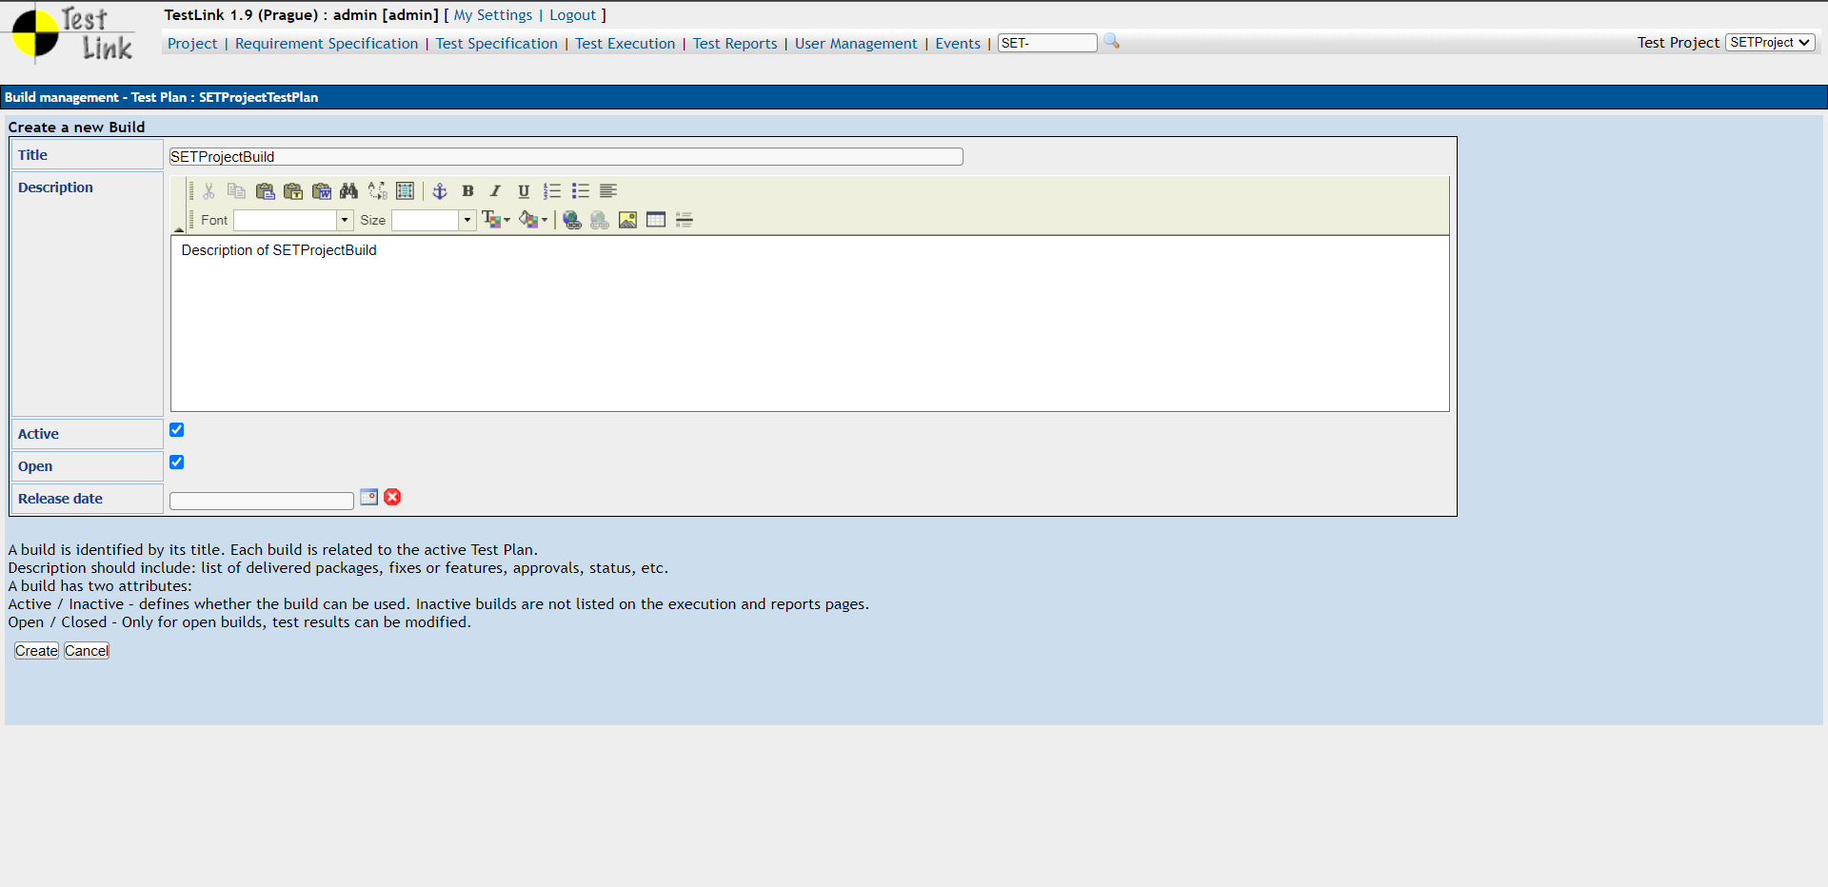

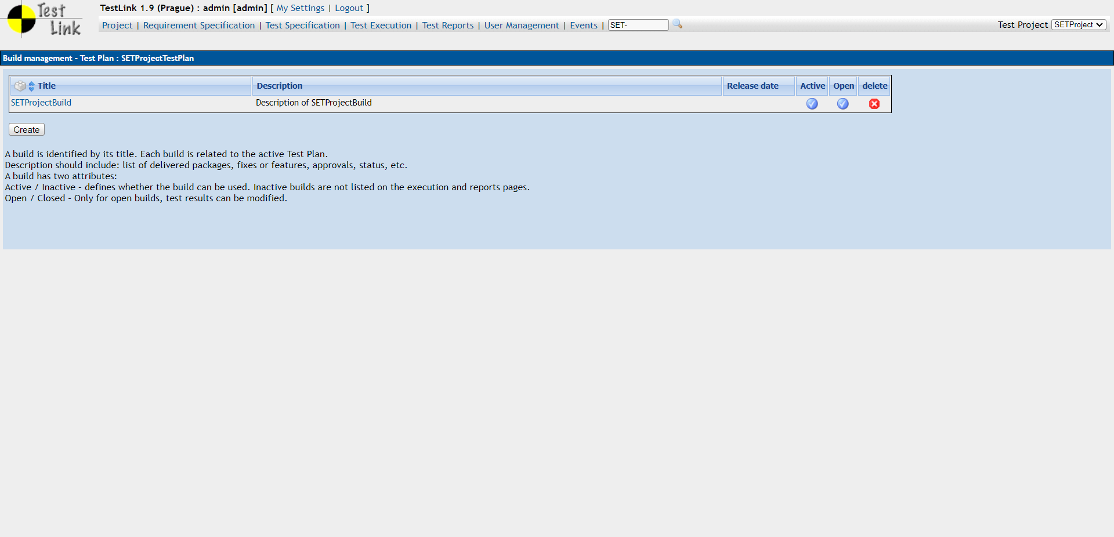

1. **Create test suite as Test Suite 1 under SETProject**

Click on the "Test Specification" tab

Click on "Create Test Suite" under SETProject

Enter the test suite name as "Test Suite 1"

Enter a brief description of the test suite

Select the test plan for the test suite

Click on "Create Test Suite"

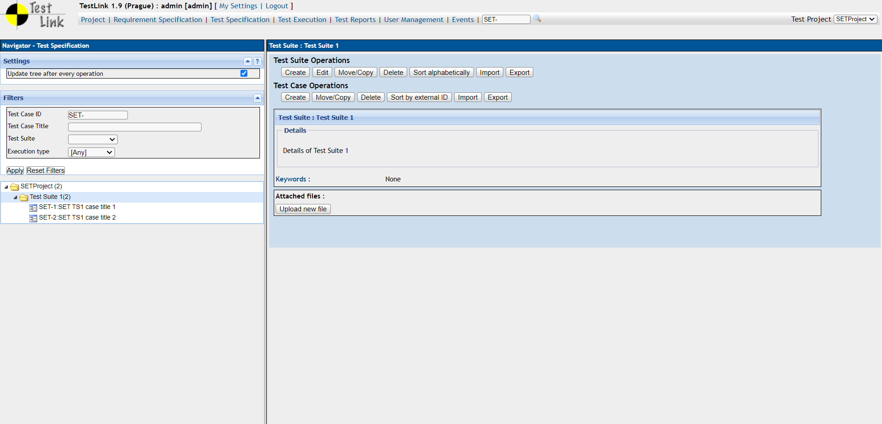

1. **Create Test cases in TestLink Tool**

Click on "Create Test Case" under "Test Specification"

Enter the test case title and summary

Select the test suite to which the test case belongs

Add the steps to execute the test case and expected results

Add any preconditions and post-conditions

Click on "Create Test Case"

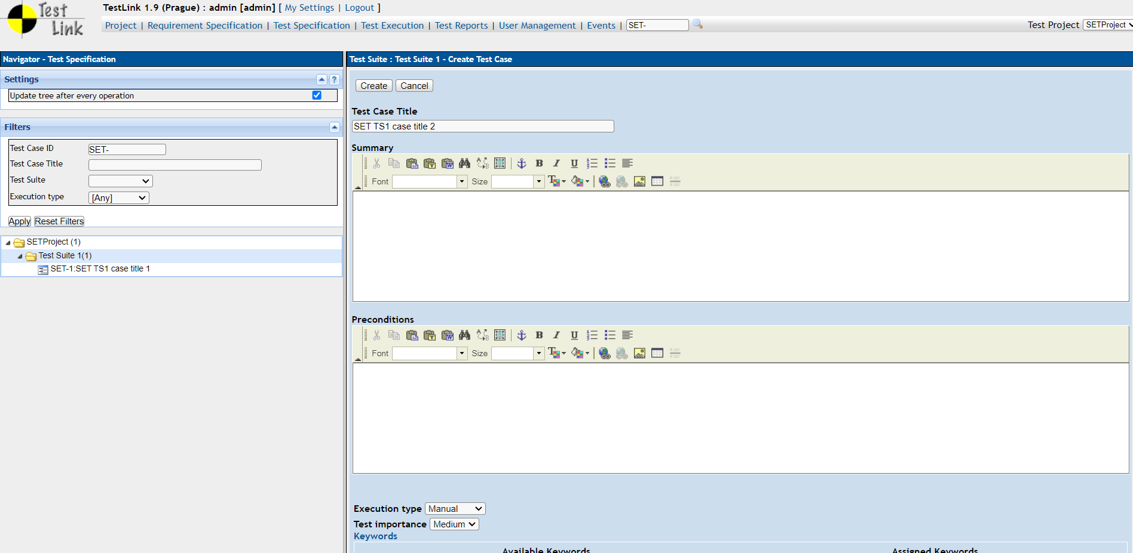

1. **Assign created Test Cases to the test plan SETProjectTestPlan**

Click on the "Test Plan Management" tab

Select the SETProjectTestPlan

Click on the "Test Case Assignment" tab

Select the test cases to be assigned to the test plan

Click on "Assign Test Case(s) to Test Plan"

1. **Create different roles as given below in the TestLink**

Click on the "User Management" tab

Click on "Define Roles" under SETProject

Create different roles like "Tester," "Test Manager," "Developer," etc.

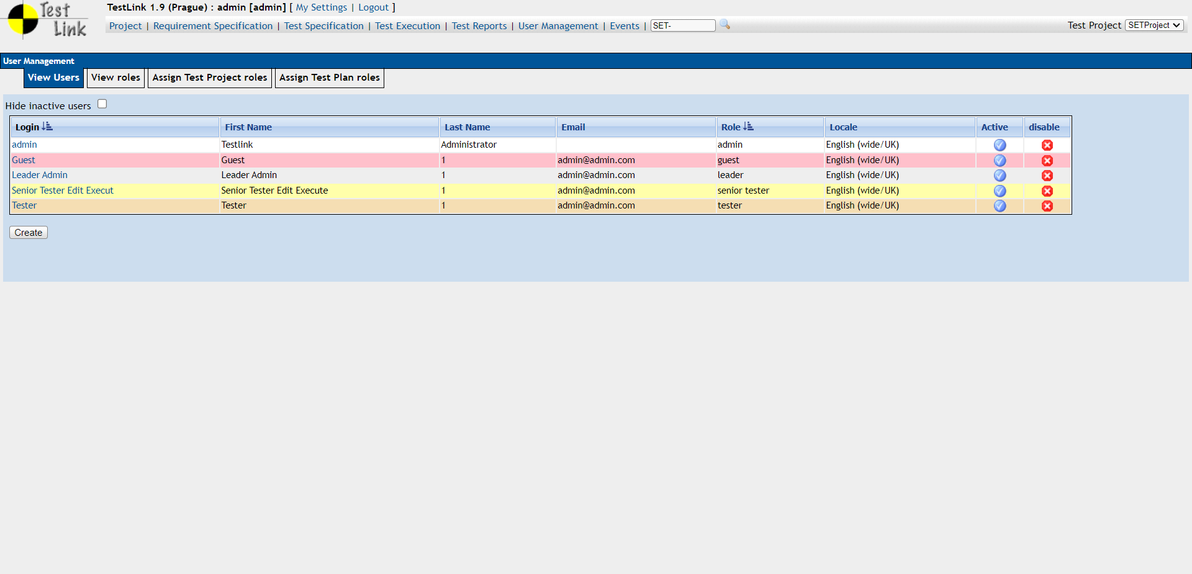

1. **Write a requirements in TestLink**

Click on the "Requirements Specification" tab

Click on "Create Requirement Specification"

Enter the requirement name and description

Assign the requirement to a test plan

Click on "Create Requirement Specification"

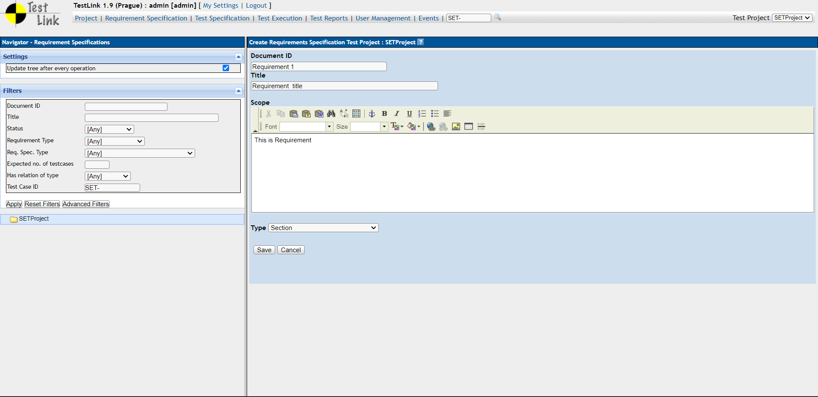

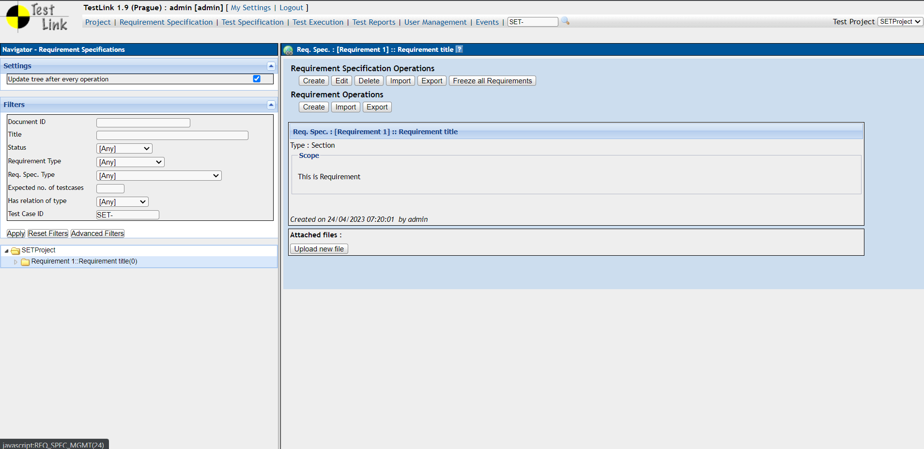

1. **Execute test cases**

Click on the "Execute Tests" tab

Select the test plan and build

Select the test cases to be executed

Assign the test cases to a tester

Execute the test cases

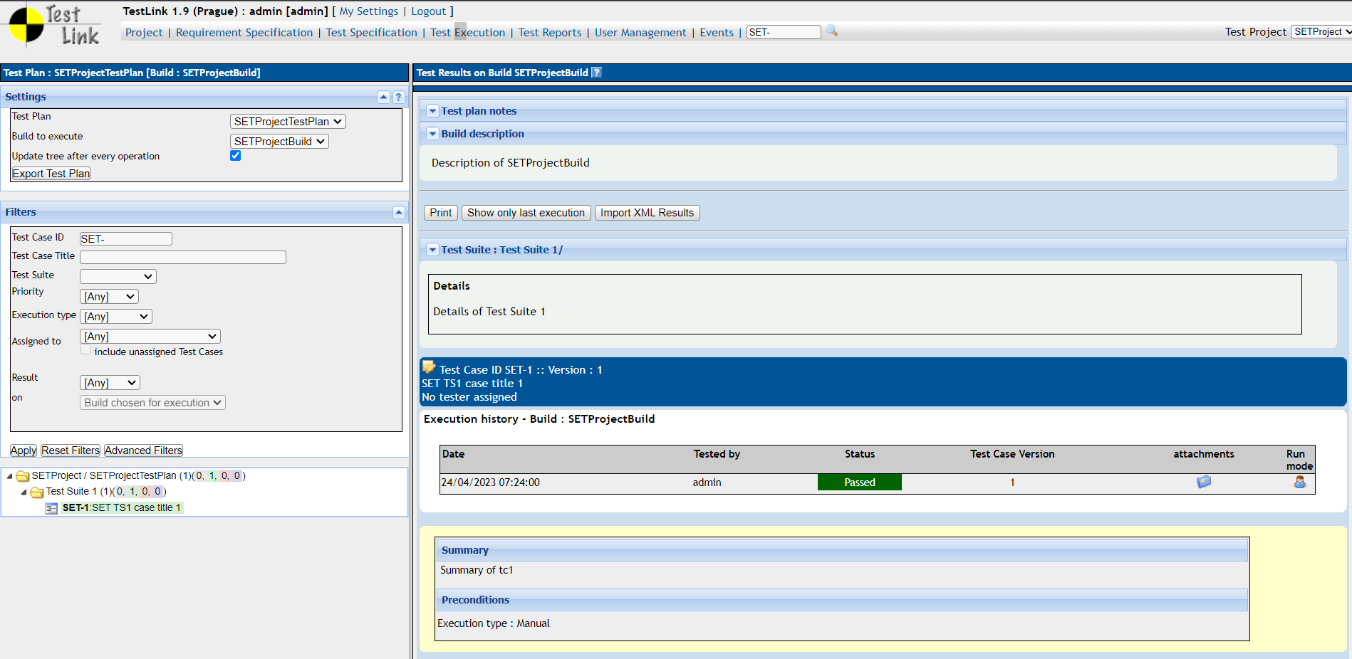

1. **Generate a test report in excel format.**

Click on the "Test Plan Management" tab

Select the SETProjectTestPlan

Click on the "Metrics" tab

Select the report type as "Excel"

Click on "Generate Report"

